Plasmit HMS ER Diagram
Database Scripts, Tables and Relationship Blueprint

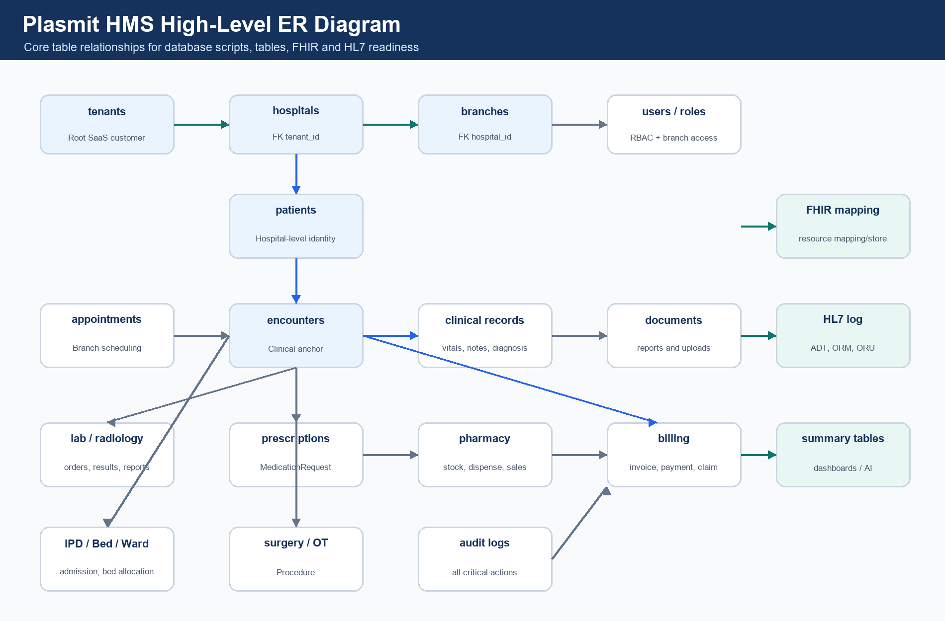

1. Purpose
This document gives a high-level ER diagram and table relationship plan for the Plasmit HMS database. It explains database scripts, table groups, module-wise tables, and key parent-child relationships.

2. Database and Script Order
- Database name: plasmit_hms
- First table: tenants
- Recommended migration tool: Flyway
- Use timestamp migration naming for multi-developer work.
Order | Script Name | Main Tables
1 | V202606030001__create_foundation_tables.sql | tenants, hospitals, branches, departments, healthcare_services
2 | V202606030002__create_user_role_permission_tables.sql | users, roles, permissions, role_permissions, user_branch_access
3 | V202606030003__create_patient_tables.sql | patients, patient_identifiers, patient_addresses, patient_contacts, patient_allergies
4 | V202606030004__create_appointment_tables.sql | appointment_slots, appointments, appointment_status_history, appointment_reminders
5 | V202606030005__create_encounter_clinical_tables.sql | encounters, encounter_participants, vitals, diagnoses, clinical_notes, procedures, care_plans
6 | V202606030006__create_prescription_medication_tables.sql | prescriptions, prescription_items, medication_administration_records
7 | V202606030007__create_lab_radiology_tables.sql | lab_orders, lab_order_items, lab_samples, lab_results, diagnostic_reports, radiology_orders, radiology_reports
8 | V202606030008__create_pharmacy_inventory_tables.sql | medicine_master, medicine_batches, pharmacy_stock, stock_movements, pharmacy_sales
9 | V202606030009__create_billing_insurance_tables.sql | billing_invoices, billing_invoice_items, payments, refunds, insurance_claims
10 | V202606030010__create_ipd_surgery_document_audit_tables.sql | admissions, wards, rooms, beds, surgery_cases, documents, audit_logs
11 | V202606030011__create_fhir_hl7_tables.sql | fhir_resource_mapping, fhir_resource_store, hl7_message_log, hl7 mappings
12 | V202606030012__create_reporting_summary_tables.sql | daily summaries, snapshots, patient_journey_summary

3. High-Level ER Diagram

This visual ER diagram shows the main relationship flow: tenant to hospital, hospital to branch, hospital to patient, patient to encounter, and encounter to clinical, diagnostics, pharmacy, billing and documents.

4. Mermaid ER Diagram
erDiagram
tenants ||--o{ hospitals : owns
hospitals ||--o{ branches : has
hospitals ||--o{ departments : defines
departments ||--o{ healthcare_services : offers
hospitals ||--o{ users : employs
users ||--o{ user_branch_access : receives
branches ||--o{ user_branch_access : allows
roles ||--o{ role_permissions : maps
permissions ||--o{ role_permissions : maps
hospitals ||--o{ patients : registers
patients ||--o{ patient_identifiers : has
patients ||--o{ patient_addresses : has
patients ||--o{ patient_contacts : has
patients ||--o{ patient_allergies : has
patients ||--o{ appointments : books
branches ||--o{ appointments : schedules
users ||--o{ appointments : attends
appointments ||--o| encounters : creates
patients ||--o{ encounters : visits
branches ||--o{ encounters : hosts
encounters ||--o{ encounter_participants : includes
users ||--o{ encounter_participants : participates
encounters ||--o{ vitals : records
encounters ||--o{ diagnoses : records
encounters ||--o{ clinical_notes : records
encounters ||--o{ procedures : performs
encounters ||--o{ care_plans : plans
encounters ||--o{ prescriptions : orders
prescriptions ||--o{ prescription_items : contains
medicine_master ||--o{ prescription_items : references
encounters ||--o{ lab_orders : requests
lab_orders ||--o{ lab_order_items : contains
lab_test_master ||--o{ lab_order_items : selected
lab_order_items ||--o{ lab_samples : collects
lab_order_items ||--o{ lab_results : produces
lab_results ||--o{ lab_result_parameters : contains
lab_results ||--o{ diagnostic_reports : publishes
encounters ||--o{ radiology_orders : requests
radiology_orders ||--o{ radiology_order_items : contains
radiology_order_items ||--o{ radiology_reports : produces
radiology_reports ||--o{ imaging_studies : references
medicine_master ||--o{ medicine_batches : has
medicine_batches ||--o{ pharmacy_stock : stocked_as
branches ||--o{ pharmacy_stock : owns
pharmacy_sales ||--o{ pharmacy_sale_items : contains
medicine_batches ||--o{ pharmacy_sale_items : issued_from
encounters ||--o{ billing_invoices : bills
billing_invoices ||--o{ billing_invoice_items : contains
billing_invoices ||--o{ payment_allocations : receives
payments ||--o{ payment_allocations : allocates
patients ||--o{ insurance_policies : has
billing_invoices ||--o{ insurance_claims : claims
insurance_claims ||--o{ insurance_claim_items : contains
encounters ||--o{ admissions : admits
branches ||--o{ wards : has
wards ||--o{ rooms : contains
rooms ||--o{ beds : contains
admissions ||--o{ bed_allocations : assigns
admissions ||--o{ nursing_notes : records
admissions ||--o{ discharge_summaries : generates
branches ||--o{ operation_theatres : has
encounters ||--o{ surgery_cases : schedules
surgery_cases ||--o{ surgery_team_members : includes
surgery_cases ||--o{ surgery_checklists : checks
patients ||--o{ documents : owns
encounters ||--o{ documents : produces
documents ||--o{ document_versions : versions
documents ||--o{ document_access_logs : audits
users ||--o{ audit_logs : performs
patients ||--o{ patient_record_access_logs : accessed
patients ||--o{ consent_records : consents
fhir_resource_mapping }o--|| patients : maps
fhir_resource_mapping }o--|| encounters : maps
hl7_message_log ||--o{ hl7_patient_mapping : maps
hl7_message_log ||--o{ hl7_order_mapping : maps
hl7_message_log ||--o{ hl7_result_mapping : maps

5. Module-Wise Table Catalog
Module | Tables | Purpose
Foundation | tenants, hospitals, branches, departments, healthcare_services | Tenant -> Hospital -> Branch -> Service hierarchy
Access Control | users, roles, permissions, role_permissions, user_branch_access | Login, RBAC and branch access
Patient | patients, patient_identifiers, patient_addresses, patient_contacts, patient_allergies, patient_insurance, patient_documents, patient_consent_records | Hospital-level patient record
Appointment | appointment_slots, appointments, appointment_status_history, appointment_reminders, appointment_cancellations | Branch-level scheduling
Encounter / Clinical | encounters, encounter_participants, encounter_status_history, vitals, diagnoses, clinical_notes, clinical_documents, procedures, care_plans | Clinical source of truth
Prescription / Medication | prescriptions, prescription_items, medicine_master, medication_instructions, medication_administration_records | Medication orders and administration
Lab / Diagnostics | lab_test_master, lab_test_parameters, lab_orders, lab_order_items, lab_samples, lab_results, lab_result_parameters, diagnostic_reports | Order to result workflow
Radiology | radiology_test_master, radiology_orders, radiology_order_items, radiology_reports, imaging_studies | Imaging order to report workflow
Pharmacy / Inventory | medicine_categories, medicine_batches, pharmacy_stock, stock_movements, pharmacy_sales, pharmacy_sale_items, pharmacy_returns, purchase_orders, goods_receipts | Stock, dispensing and procurement
Billing / Insurance | billing_invoices, billing_invoice_items, payments, payment_allocations, refunds, insurance_policies, insurance_claims, insurance_claim_items | Revenue cycle
IPD / Nursing / Bed | admissions, wards, rooms, beds, bed_allocations, nursing_notes, nursing_tasks, discharge_plans, discharge_summaries | Admission and bed management
Surgery / OT | operation_theatres, surgery_cases, surgery_team_members, surgery_checklists, anesthesia_records, surgery_notes | Operation theatre workflow
Documents | documents, document_versions, document_access_logs, document_signatures | Reports, uploads and signed documents
Audit / Compliance | audit_logs, user_login_history, patient_record_access_logs, consent_records, break_glass_access_logs, data_export_logs | Compliance and access traceability
FHIR Integration | fhir_resource_mapping, fhir_resource_store, fhir_api_audit_log, fhir_sync_status, fhir_profile_registry, fhir_code_system_mapping | FHIR resource mapping and API audit
HL7 Integration | hl7_message_log, hl7_message_error_log, hl7_external_identifier_mapping, hl7_patient_mapping, hl7_order_mapping, hl7_result_mapping | HL7 inbound/outbound mapping
Reporting | daily_branch_revenue_summary, daily_patient_visit_summary, doctor_performance_summary, department_collection_summary, lab_test_volume_summary, pharmacy_stock_snapshot, bed_occupancy_summary, patient_journey_summary | Dashboards and AI command center

6. Main Table Relationships
Parent Table | Child Table | Relationship | Join Key | Business Meaning
tenants | hospitals | 1:N | hospitals.tenant_id | One tenant/hospital group owns many hospitals.
hospitals | branches | 1:N | branches.hospital_id | One hospital has many branches/facilities.
hospitals | patients | 1:N | patients.hospital_id | Patient is hospital-level by default.
branches | appointments | 1:N | appointments.branch_id | Appointments are branch-level.
patients | appointments | 1:N | appointments.patient_id | One patient can book many appointments.
patients | encounters | 1:N | encounters.patient_id | One patient can have many visits.
branches | encounters | 1:N | encounters.branch_id | Encounter is branch-level.
appointments | encounters | 0/1:1 | encounters.appointment_id | Appointment may create encounter.
encounters | vitals | 1:N | vitals.encounter_id | Vitals belong to encounter.
encounters | diagnoses | 1:N | diagnoses.encounter_id | Diagnosis belongs to encounter.
encounters | clinical_notes | 1:N | clinical_notes.encounter_id | Clinical notes belong to encounter.
encounters | prescriptions | 1:N | prescriptions.encounter_id | Prescription belongs to encounter.
prescriptions | prescription_items | 1:N | prescription_items.prescription_id | Prescription has many medicine lines.
encounters | lab_orders | 1:N | lab_orders.encounter_id | Lab order belongs to encounter.
lab_orders | lab_order_items | 1:N | lab_order_items.lab_order_id | Lab order has many tests.
lab_order_items | lab_results | 1:N | lab_results.lab_order_item_id | Test item creates results.
encounters | radiology_orders | 1:N | radiology_orders.encounter_id | Radiology order belongs to encounter.
radiology_order_items | radiology_reports | 1:N | radiology_reports.radiology_order_item_id | Radiology item creates report.
medicine_master | medicine_batches | 1:N | medicine_batches.medicine_id | Medicine has many batches.
medicine_batches | pharmacy_stock | 1:N | pharmacy_stock.medicine_batch_id | Batch stock is branch-wise.
pharmacy_sales | pharmacy_sale_items | 1:N | pharmacy_sale_items.sale_id | Sale has many items.
encounters | billing_invoices | 1:N | billing_invoices.encounter_id | Encounter may generate invoices.
billing_invoices | billing_invoice_items | 1:N | billing_invoice_items.invoice_id | Invoice has charge lines.
billing_invoices | payment_allocations | 1:N | payment_allocations.invoice_id | Payment is allocated to invoices.
payments | payment_allocations | 1:N | payment_allocations.payment_id | One payment may cover multiple invoices.
encounters | admissions | 0/1:N | admissions.encounter_id | IPD admission starts from encounter.
wards | rooms | 1:N | rooms.ward_id | Ward contains rooms.
rooms | beds | 1:N | beds.room_id | Room contains beds.
admissions | bed_allocations | 1:N | bed_allocations.admission_id | Admission can have multiple bed allocations.
encounters | surgery_cases | 1:N | surgery_cases.encounter_id | Surgery belongs to encounter.
patients | documents | 1:N | documents.patient_id | Documents are linked to patient.
encounters | documents | 1:N | documents.encounter_id | Documents may also link to encounter.
users | audit_logs | 1:N | audit_logs.performed_by | Every critical user action is audited.
internal tables | fhir_resource_mapping | 1:N | internal_table_name + internal_record_id | Internal records map to FHIR resources.
external systems | hl7_message_log | 1:N | message_control_id | Inbound/outbound HL7 messages are logged.

7. First Tables in Exact Order
Order | Table | Why First
1 | tenants | Root SaaS customer/hospital group.
2 | hospitals | Every hospital belongs to a tenant.
3 | branches | Operational data is branch-specific.
4 | departments | Hospital/branch service departments.
5 | healthcare_services | Services offered by departments.
6 | users | Doctors, staff and admins.
7 | roles | Role master for RBAC.
8 | permissions | Permission master for access control.
9 | role_permissions | Role to permission mapping.
10 | user_branch_access | Defines which user can access which branch.

8. Tenant Isolation Rules
Table Type | Required Columns | Examples
Global master | id, code, name | country_master, gender_master
Tenant-level | tenant_id | tenant_settings
Hospital-level | tenant_id, hospital_id | patients, departments, medicine_master
Branch-level | tenant_id, hospital_id, branch_id | appointments, encounters, lab_orders, billing_invoices, pharmacy_stock
Encounter-level | tenant_id, hospital_id, branch_id, patient_id, encounter_id | vitals, diagnoses, prescriptions, lab_results

9. Final Recommendation
- Create database plasmit_hms first.
- Create tenants table first.
- Create foundation and access-control tables before patient and clinical tables.
- Keep patient hospital-level and encounter branch-level.
- Connect lab, radiology, prescription, pharmacy, billing and documents mostly through encounter.
- Create FHIR and HL7 mapping tables after core transactional tables.
- Create reporting summary tables last.

